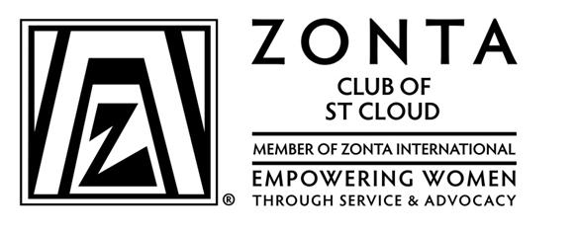

YES! Our company wants to support efforts on behalf of Anna Marie’s Alliance, Terebinth Refuge, and local/international scholarships for women, with an emphasis on the following areas:
- STEM (science, technology, engineering, mathematics)
- Young women pursuing an MBA degree
- Young women in Public Affairs
- Non-tradition female student scholars

Your sponsorship at one of the following levels would greatly serve our community:

- Platinum Level $1,000 or more contribution
- Gold Level $ 500 contribution
- Silver Level $ 250 contribution
- Bronze Level $ 125 contribution
- Other

Name of Company___________________________________________________________________________

Address ____________________________________________________________________________

Phone Number _______________________________ Email __________________________________

Contact Person ______________________________________________________________________

Make your check payable to Zonta Club of St. Cloud and
Send your contribution to Zonta Christmas House, PO Box 7453, St Cloud, MN 56302-7453

Please respond by November 1, 2023, so we can acknowledge you in a variety of our
marketing campaign efforts.

Thanks for your generous support!

